## Prerequisite :

A transaction is a unit of work that is performed against a database. Transactions are units or sequences of work accomplished in a logical order, whether in a manual fashion by a user or automatically by some sort of a database program.

A transaction is the propagation of one or more changes to the database. For example, if you are creating a record or updating a record or deleting a record from the table, then you are performing transaction on the table. It is important to control transactions to ensure data integrity and to handle database errors.

## Properties of Transactions:

## Transactions have the following four standard properties, usually referred to by the acronym ACID:

* **Atomicity:** ensures that all operations within the work unit are completed successfully; otherwise, the transaction is aborted at the point of failure, and previous operations are rolled back to their former state.
* **Consistency:** ensures that the database properly changes states upon a successfully committed transaction.
* **Isolation:** enables transactions to operate independently of and transparent to each other.
* **Durability:** ensures that the result or effect of a committed transaction persists in case of a system failure.

## Transaction Control:

There are following commands used to control transactions:

* **COMMIT:** to save the changes.
* **ROLLBACK:** to rollback the changes.
* **SAVEPOINT:** creates points within groups of transactions in which to ROLLBACK
* **SET TRANSACTION:** Places a name on a transaction.

## The COMMIT Command:

The COMMIT command is the transactional command used to save changes invoked by a transaction to the database.

The COMMIT command saves all transactions to the database since the last COMMIT or ROLLBACK command.

## The SAVEPOINT Command:

A SAVEPOINT is a point in a transaction when you can roll the transaction back to a certain point without rolling back the entire transaction.

The syntax for SAVEPOINT command is as follows:

SAVEPOINT SAVEPOINT_NAME;

This command serves only in the creation of a SAVEPOINT among transactional statements. The ROLLBACK command is used to undo a group of transactions.

The syntax for rolling back to a SAVEPOINT is as follows:

ROLLBACK TO SAVEPOINT_NAME;

**Example :-**

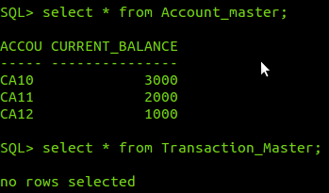

In the example given we have withdrawn an amount of 1000. Then we have created savepoint no_update . Then deposite an amount of 140000 if the total amount exceeds 200000 then we have to rollback means undo the action of depositing money using ROLLBACK TO SAVEPOINT NO_UPDATE otherwise save the changes using COMMIT.

**1**. In this amount is less then 200000 even after depositing 140000 hence rollback action will not perform

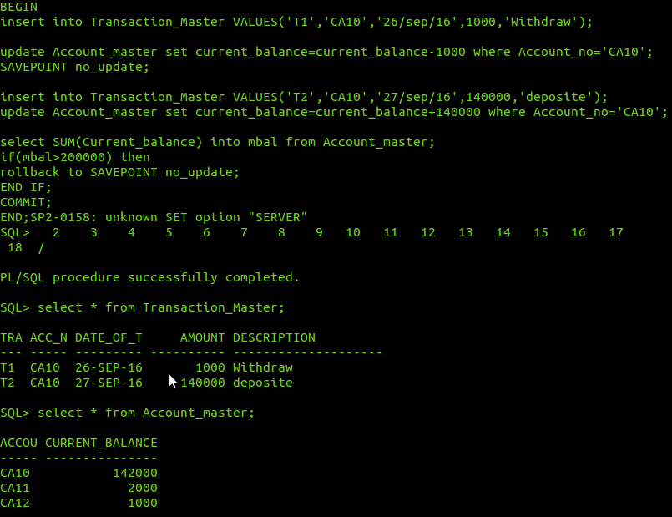

2. In this amount exceeds limit of 200000 hence rollback action will perform.

